**Task 1. Set up an RDS DB instance**

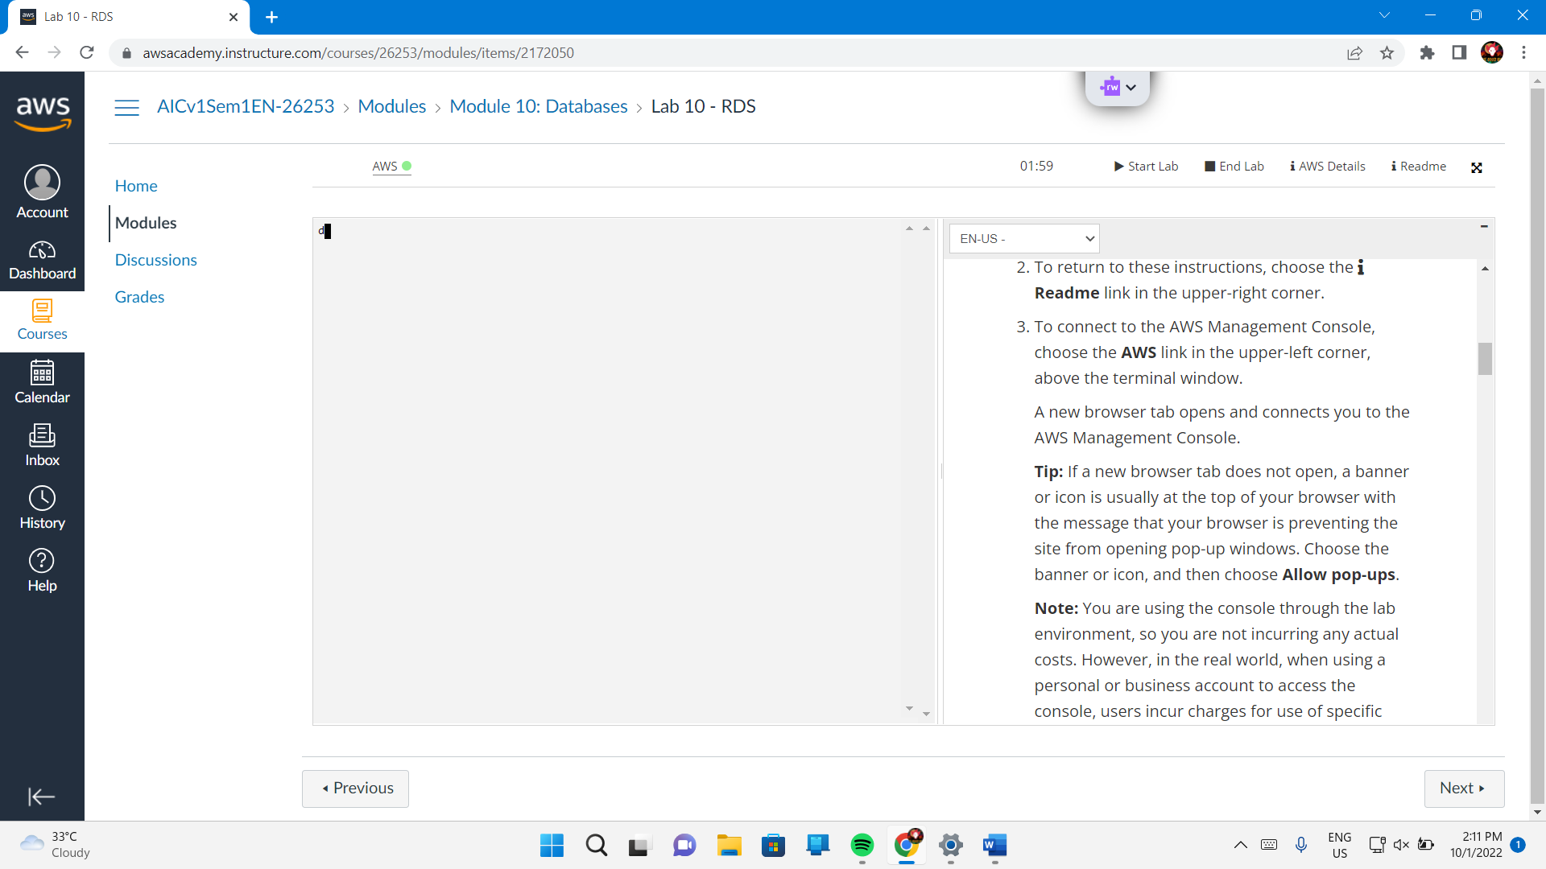

Services – Database – RDS

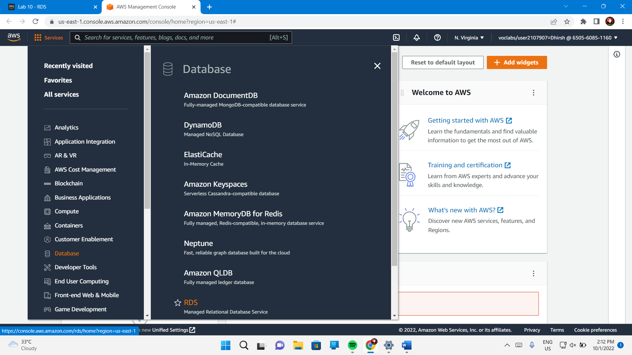

Create Database

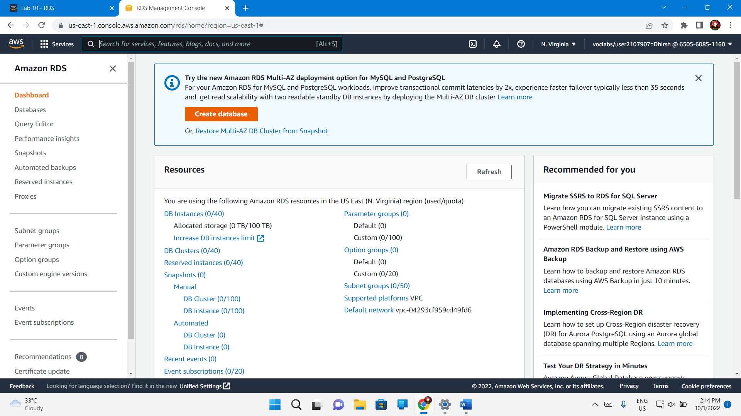

Choose database creation – Easy Create

Configuration – Microsoft sql server

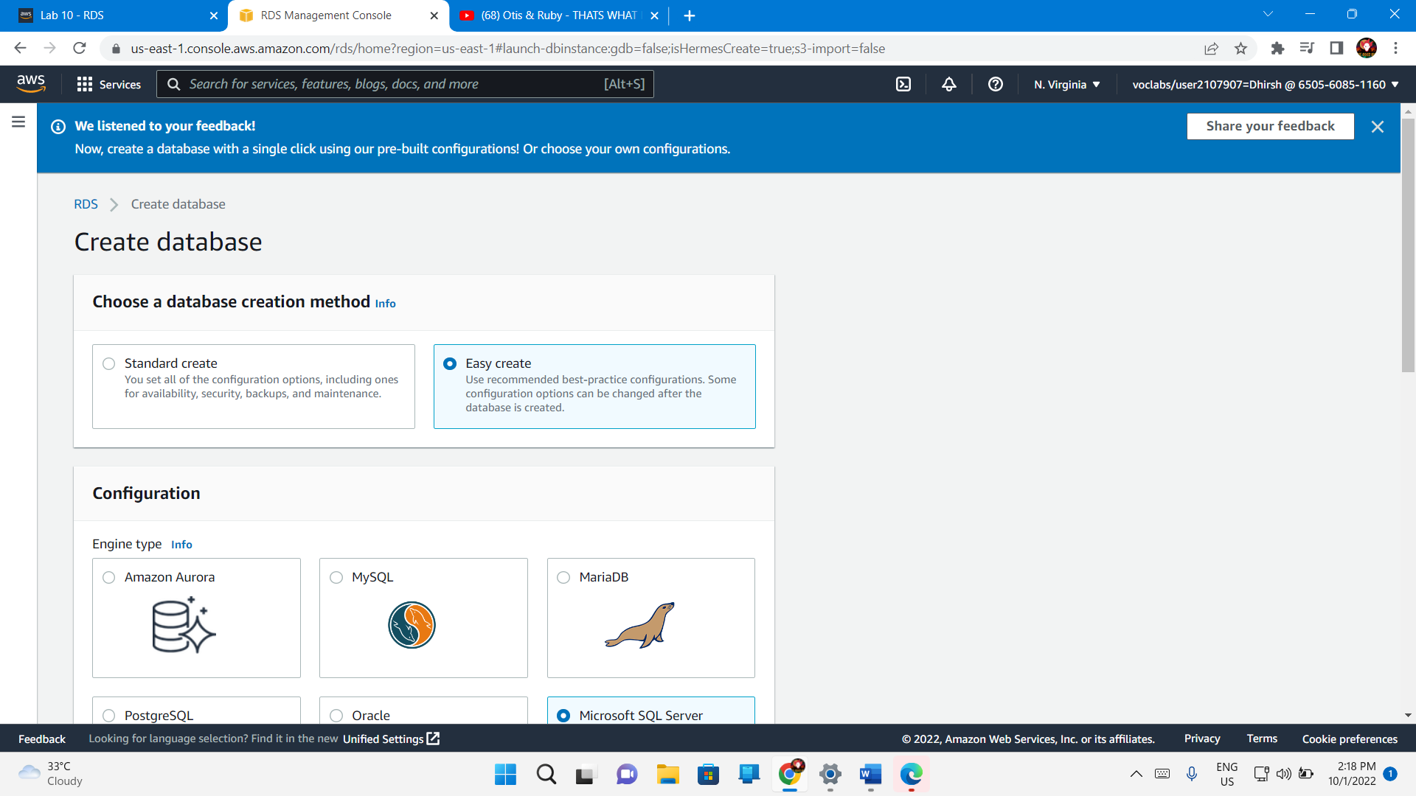

Db instance size – Free tier

Auto generate password

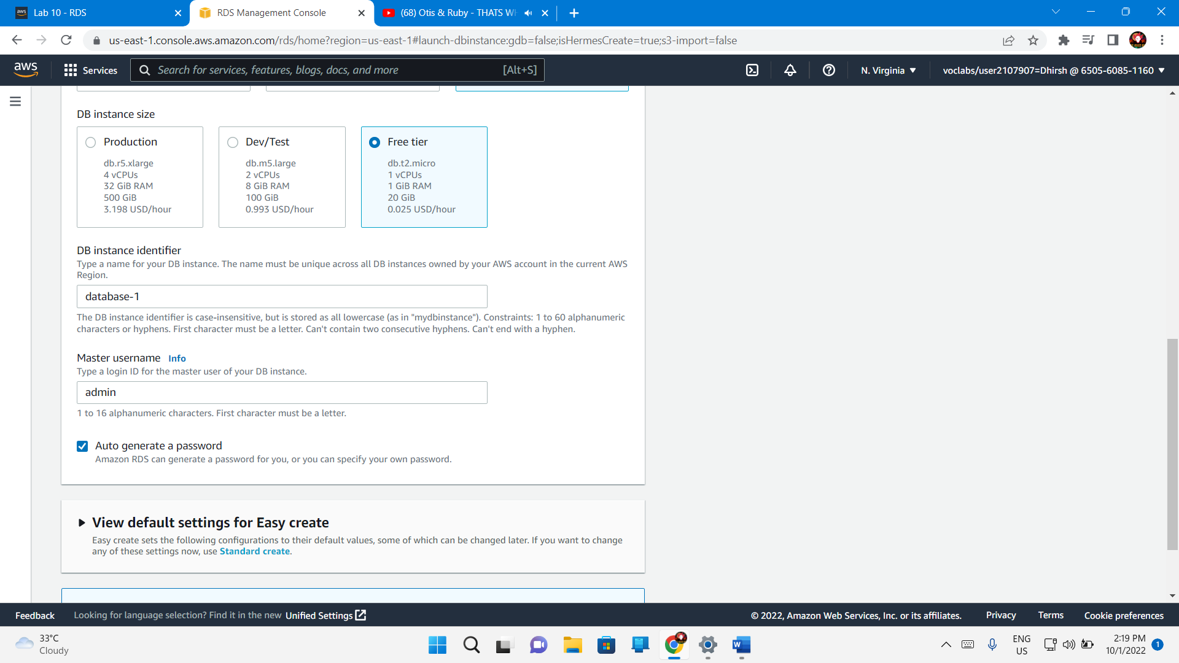

Create database

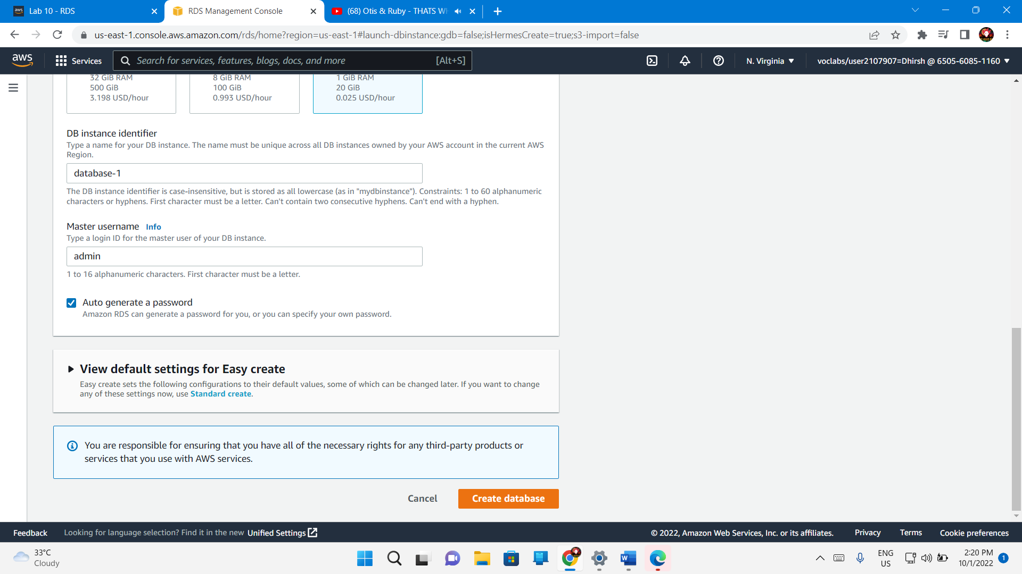

yOrRq4bNMDScdjfURM5p - password

## Download and install SQL Server Management Studio

Download sql

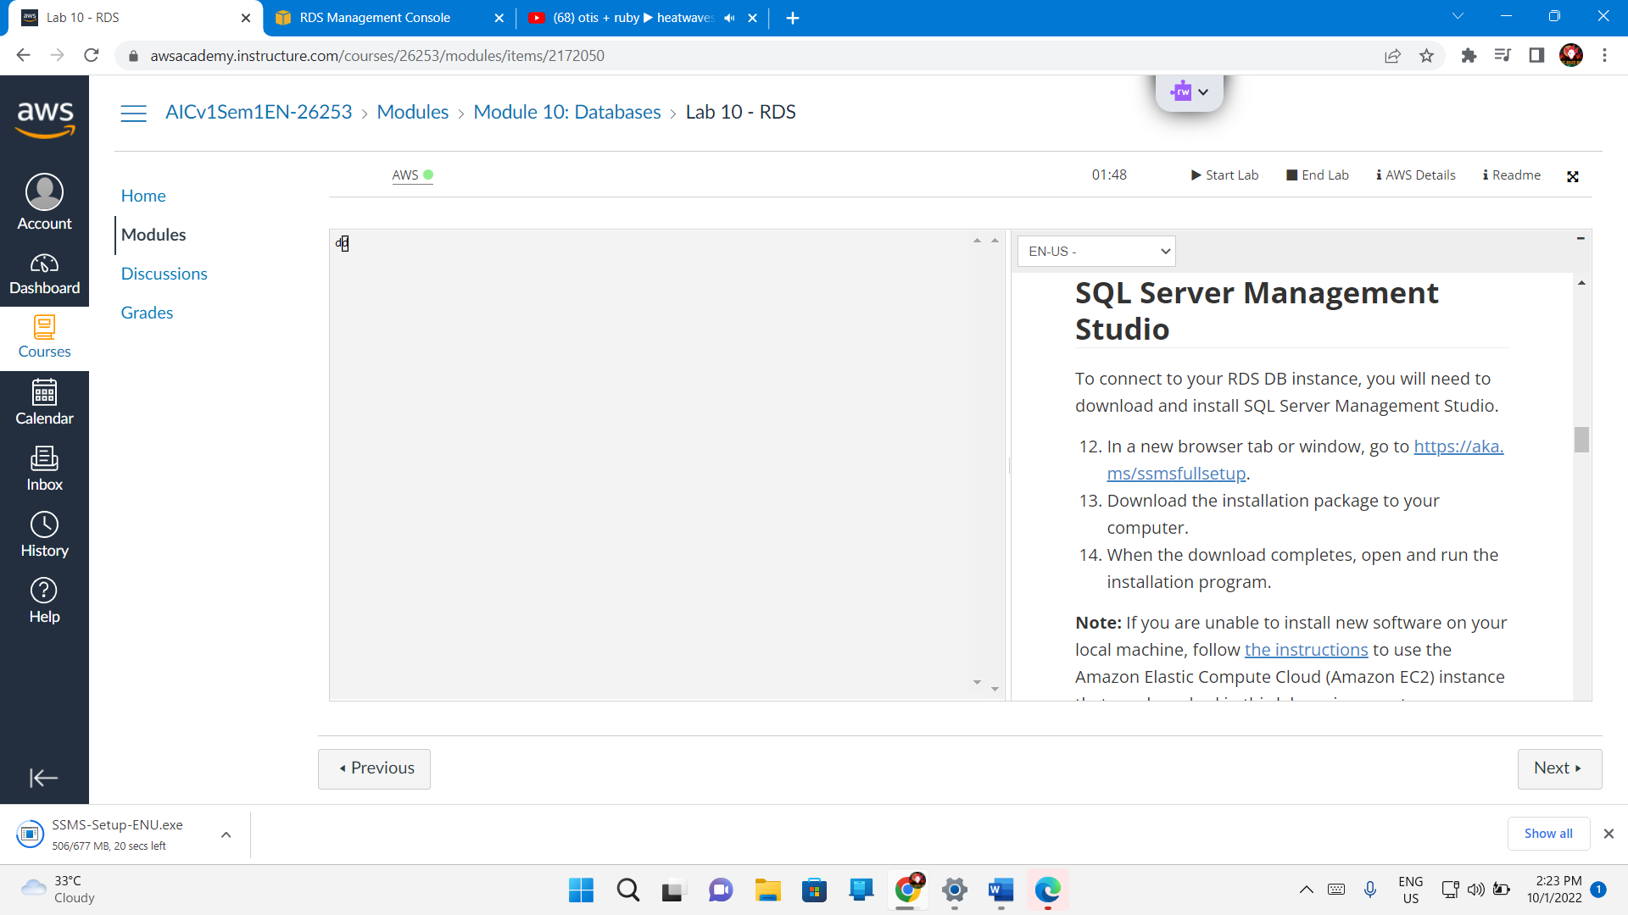

## Task 3. Make your database publicly accessible

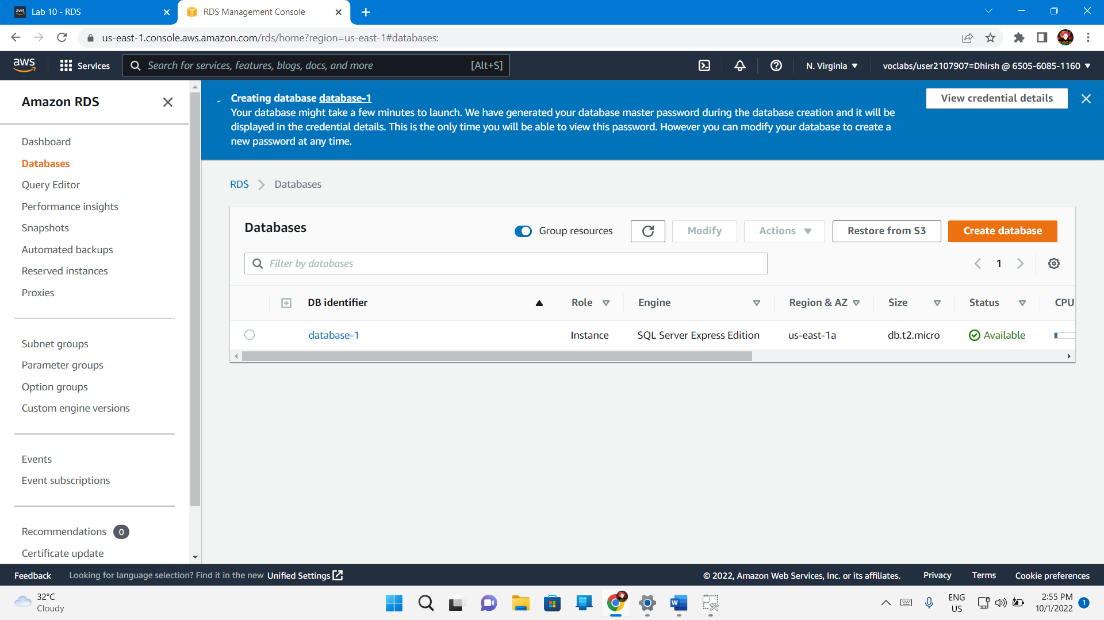

Connectivity and security – security – public accessibility – no

Modify – connectivity – additional configuration – public access – publicly accessible – continue

Scheduling of modifications – when to apply modifications – apply immediately

Modify db instance – status changes to modifying and then available.

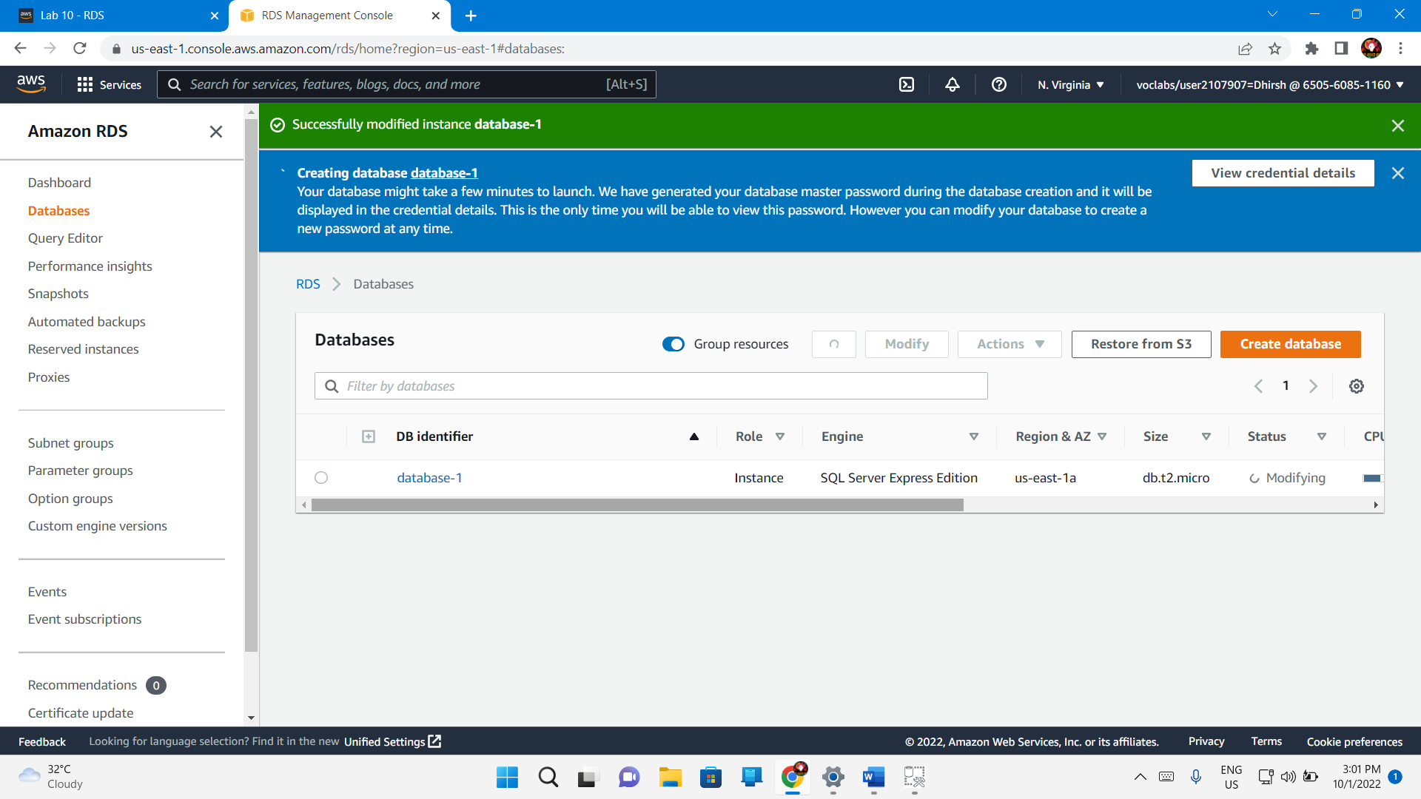

## Task 4. Update your VPC security group

In a new browser tab or window, go to <https://whatismyipaddress.com/>.

Copy the **IPv4** value to a text editor to use later in this lab.

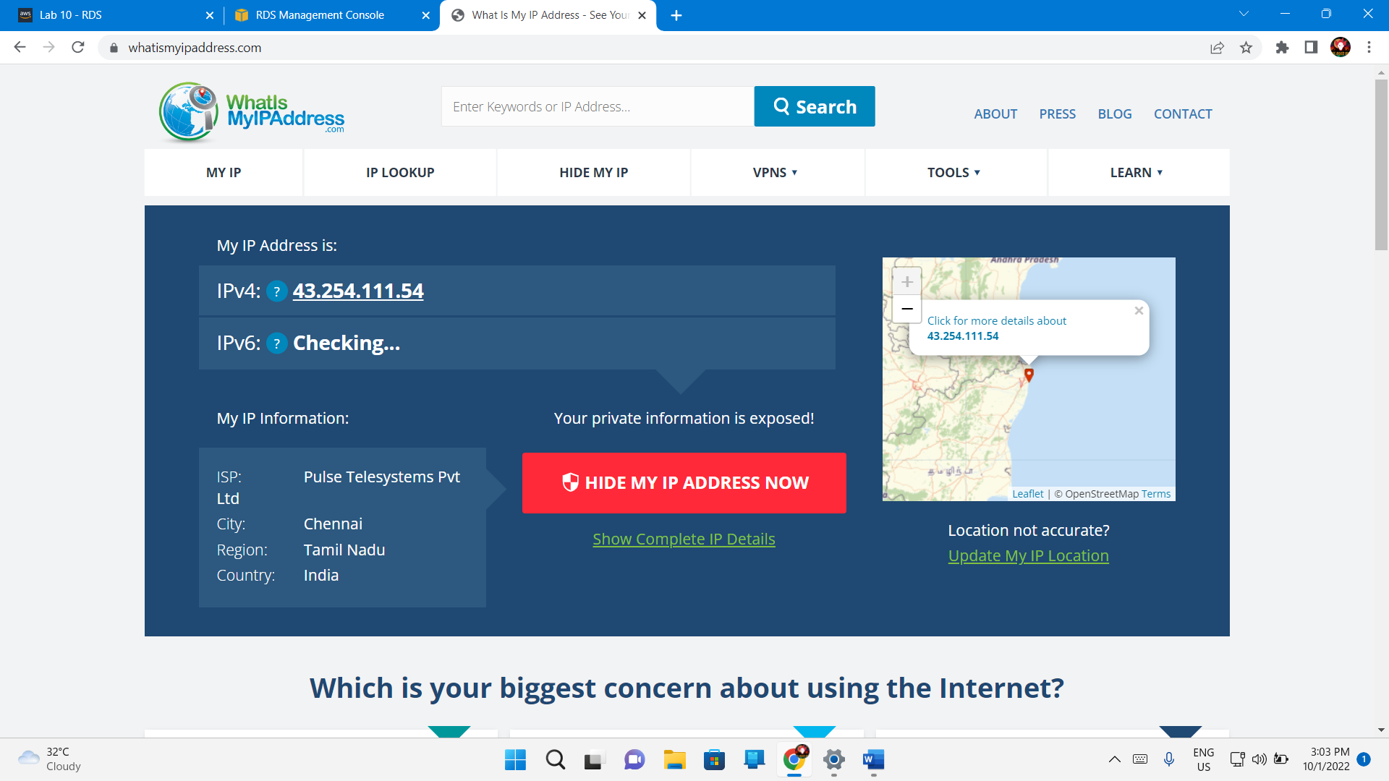

Rds – databases – connectivity and security – vpc security groups **default (sg-a12345b6)**

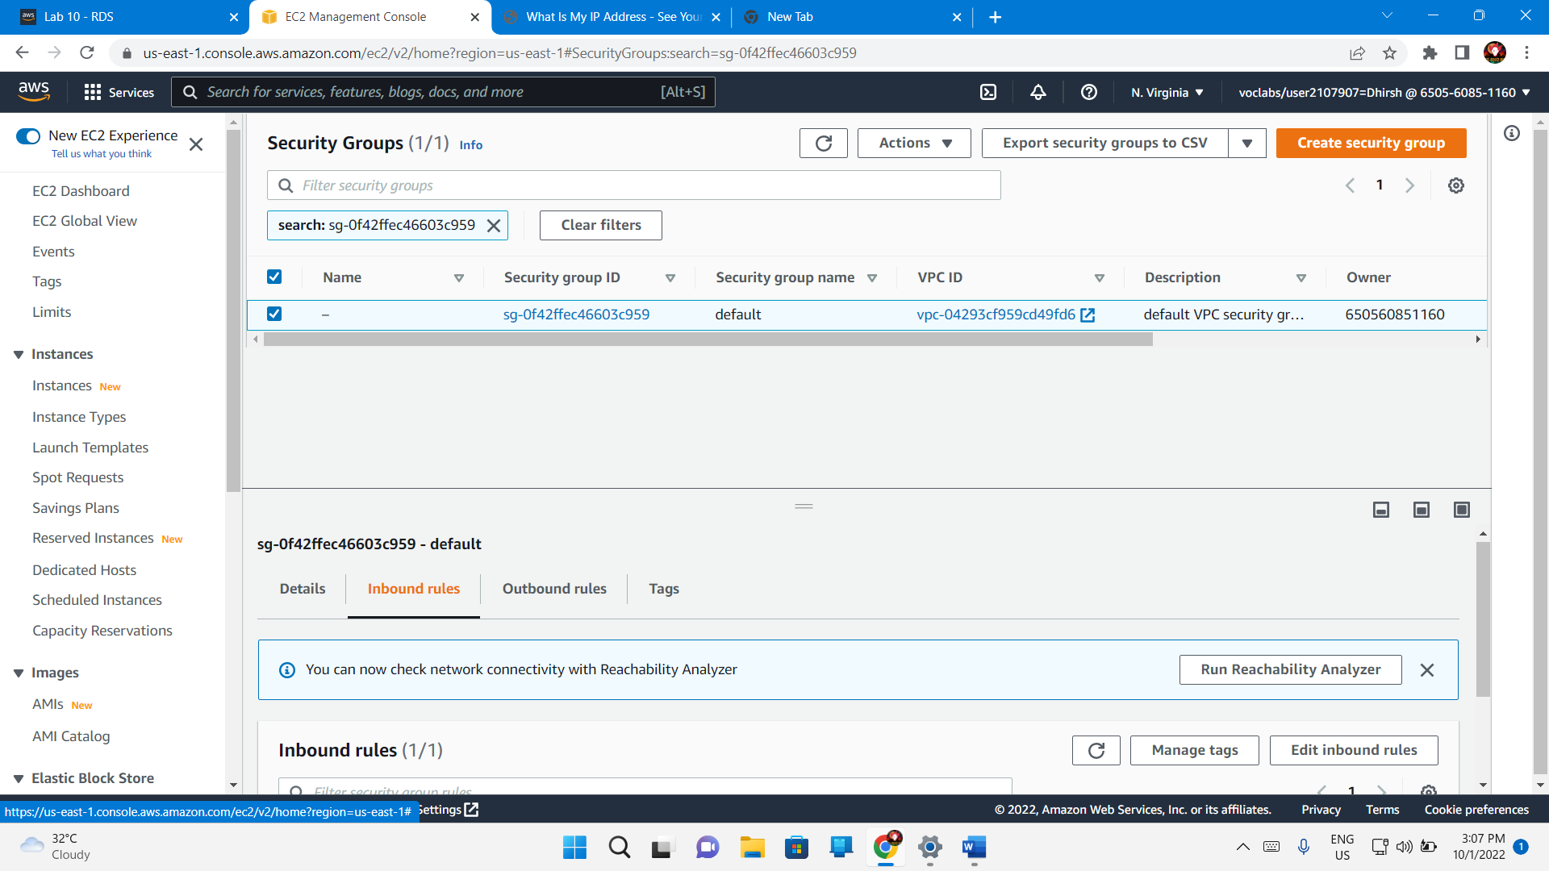

**Security groups – inbound rules – edit inbound rules – add rule**

**Type – mssql**

**Source – custom – ip address of windows workstation**

Add /32 at the end of the IP address. The full text should look similar to the following: **123.12.123.23/32**

Save rules

## Task 5. Connect to your DB instance

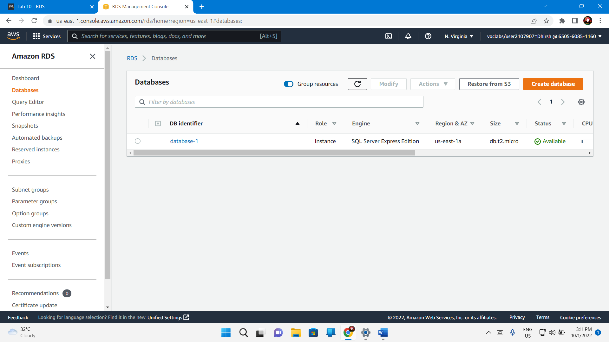

On the **Connectivity & security** tab, copy the **Endpoint** value to a text editor.

Port

1433

database-1.c4zbhpzjmezm.us-east-1.rds.amazonaws.com

Start sql server

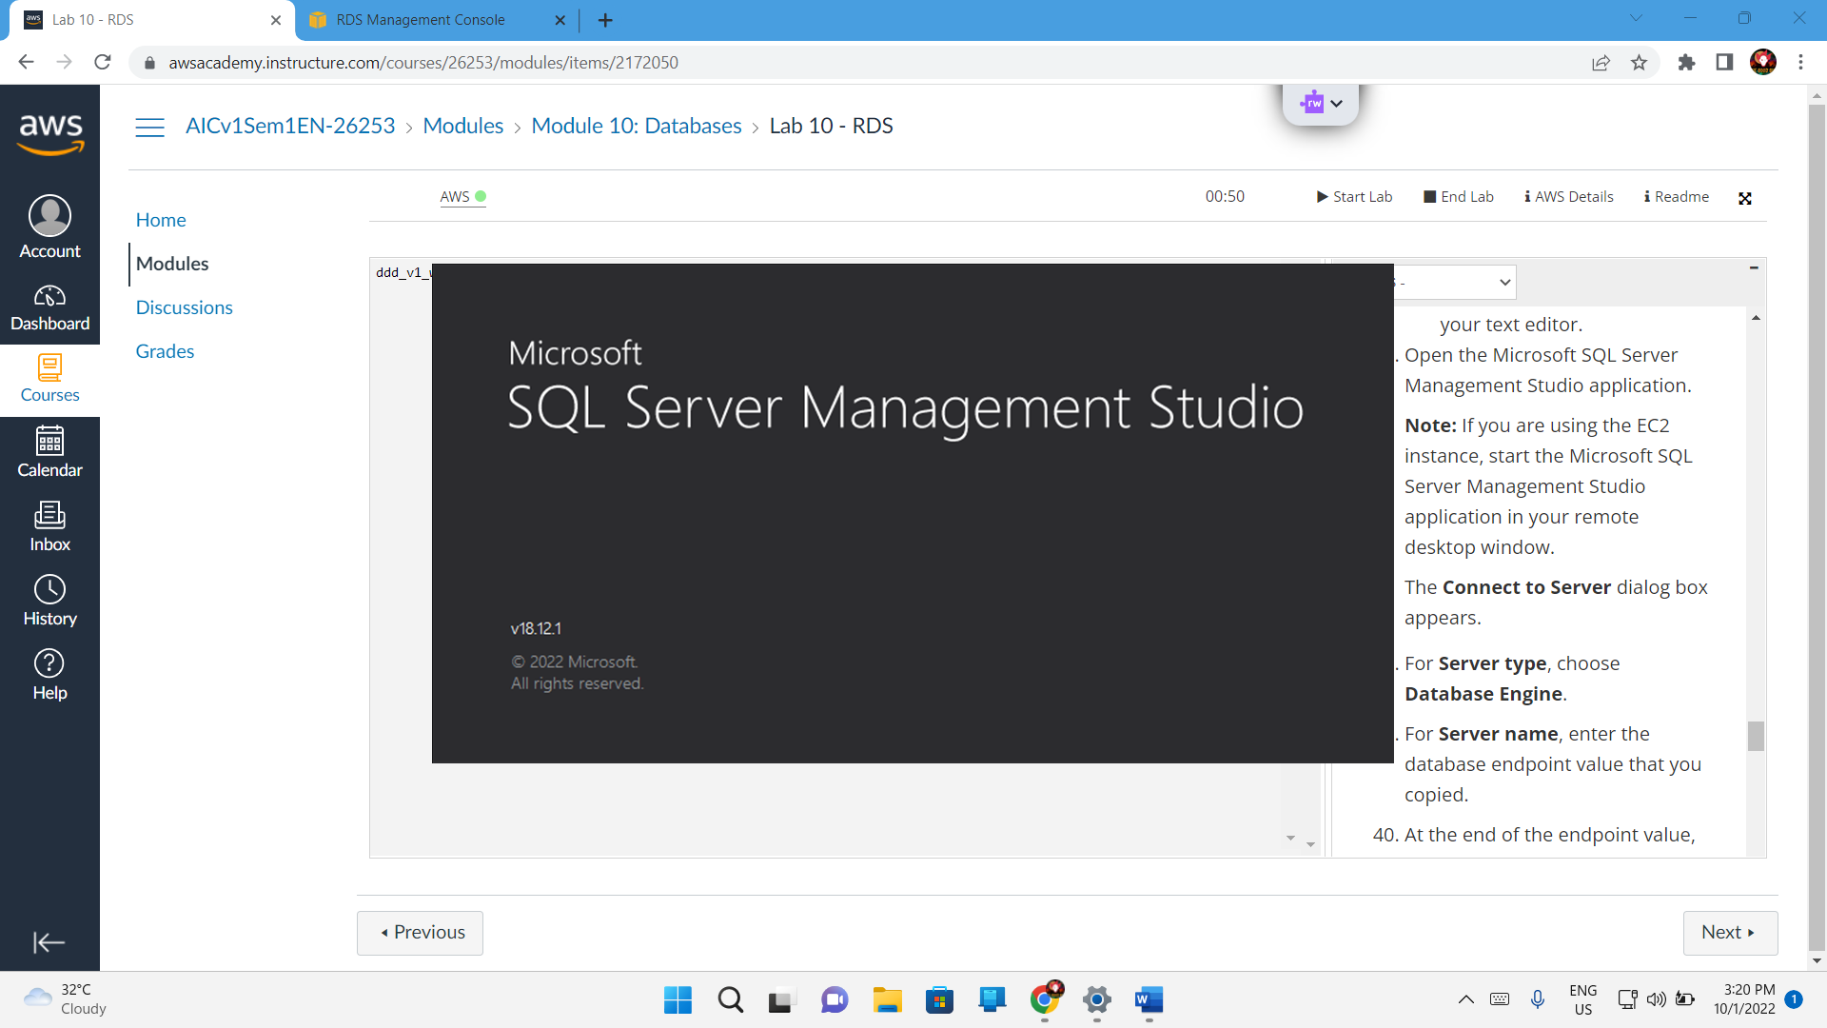

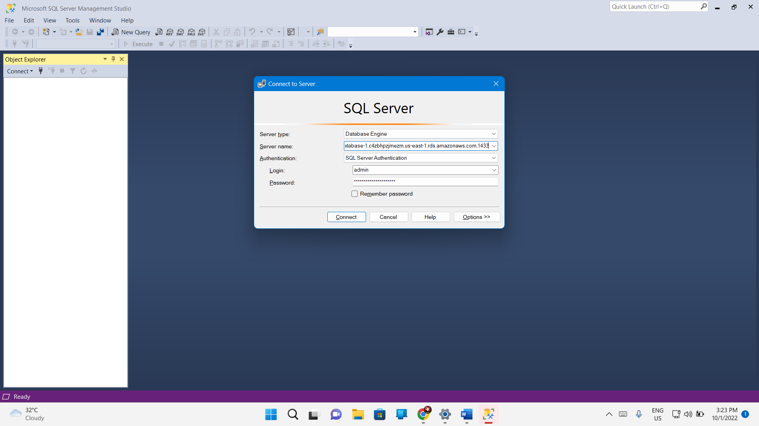

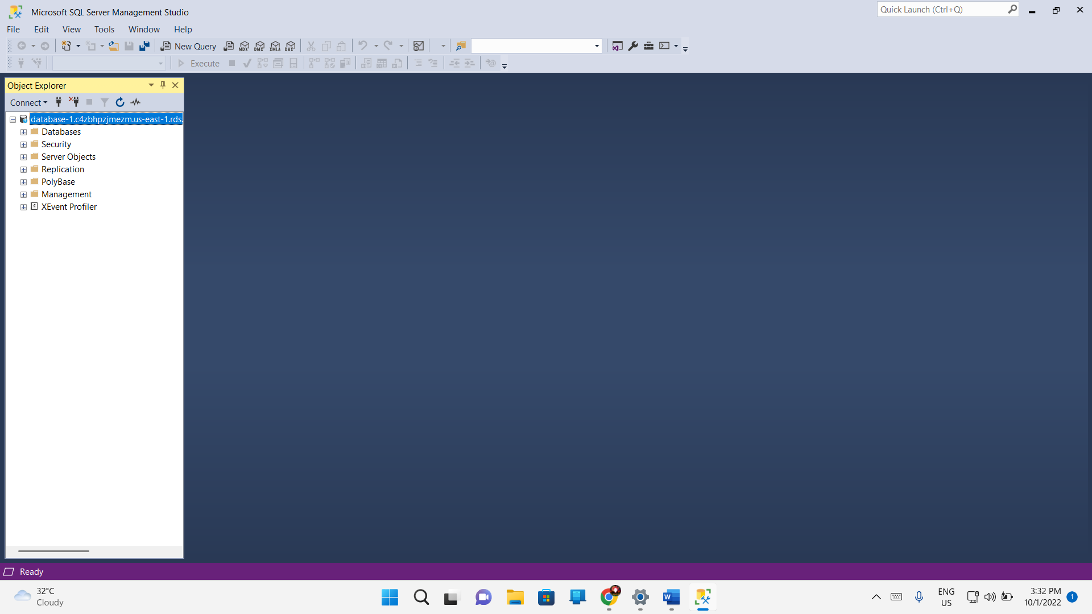

## Task 6. Explore the structure of the relational database

Great work! You can explore the structure of the relational database by expanding the areas in the **Object Explorer** pane.

You will see that the SQL Server has built-in system databases such as model, msdb, and tempdb. You can even create a new database if you would like to experiment more.

Signout



